Name:………………………………………………………….. Signature:………………

**P530/1**

**BIOLOGY**

**Nov 2020**

**2 ½ hours**

**ST. MARYS’ KITENDE**

**Uganda Advanced Certificate of Education**

**RESOURCEFUL MOCK EXAMINATION 2020**

**BIOLOGY**

**Paper 1**

**2 hours 30 minutes**

**Instructions to candidates**

Answer all questions in both section A and B

***Section A***

Answer to this section must be written in the boxes provided.

***Section B***

Answer to this section should be written in the space provided and not any where else.

No addition sheet of paper should be inserted in this booklet.

**For Examiner’s use only**

|  |  |
| --- | --- |
| Section A: 1-40 |  |
| Section B: 41 |  |
| 42 |  |
| 43 |  |
| 44 |  |
| 45 |  |
| 46 |  |
| **Total** |  |

1. The length of a cell structure on a drawing is 6mm under magnification of X600. Its actual length is;

A) 1 x 10-1μm B) 1 x 100μm

C) 1 x 101μm D) 1 x 102μm

2. Competitive enzyme inhibitors

A) bind permanently to the active site

B) change the shape of the active site

C) limit formation of enzyme-substrate complexes

D) lower activation energy of the reaction

3. Which of these structures contains genetic material that has telomers?

A) Bacterial cell B) chloroplast  
C) mitochondria D) nucleus

4. DNA polymerase in a cell synthesizes,

A) a polypeptide using DNA as a template

B) a strand of DNA using a polypeptide as a template

C) a strand of NDA using DNA as a template

D) a strand of mRNA using DNA as a template

5. 21.2% of the bases in a molecule of DNA are cytosine what percentage would be adenine?

A) 21.2% B) 28.8% C) 42.4% D) 57.6%

6. Which reaction takes place at a higher rate in an alveolus than active muscle?

1. carbondioxide + water carbonic acid

2. Carbondioxide + haemoglobin carboxyhaemoglobin

3. Haemoglobin + hydrogenions haemoglobinic acid

4. Hydrogen carbonate ions + hydrogen ions carbondioxide + water

A) 1 and 2 B) 3 and 4 C) 1 only D) 4 only

7. The graph shows changes that take place in the volume of the left ventricle during one cardiac cycle. Which point on the graph represents the start of atrial systole?

D

ventricular volume

C

A

B

Time

8. Which row correctly identifies the roles of B-lymphocytes and T-lymhocytes?

|  |  |  |  |
| --- | --- | --- | --- |
|  | **Secrete Antibodies** | **Secrete cytokines** | **Provide humoral immunity** |
| A | B | T | B |
| B | B | T | T |
| C | T | B | B |
| D | T | B | T |

9. Haemoglobin is a globular protein because it has;  
A) four cross linked polypeptide chains making a quaternary structure.

B) hydrophobic group on the inside and hydrophilic one on the outside

C) hydrophobic interactions

D) cross linked polypeptide chains which form sheets

10. Some soil borne fungi cause wilting in crop plants by growing within the xylem vessels. Which process is directly affected by the fungi?

A) cohesion between water molecules

B) development of root pressure

C) mass flow during translocation

D) uptake of water by root hair cells

11. In a DNA molecule, the base AGT codes for the amino acid serine. The base sequence of the anti-codon on the tRNA to which serine becomes attached is;

A) AGU B) GAU C) TCA D) UCA

12. The minimum number of base substitutions required to change the nucleotide sequence of the HbA (normal) allele to the Hbs (suckle cell) allele is;

A) 1 B) 2 C) 3 D) 4

13. The enzyme lysozyme secreted from tear glands forms deposits on contact lenses. Which of the following would best clean the deposits?

A) ethanol B) lysosomes

C) pH buffers D) proteases

14. Which diagram represents part of the ring form of a molecule of B-glucose?

CH2OH

H

OH

OH

H

CH2OH

O

A) B)

OH

H

OH

H

O

H

OH

H

OH

O

CH2OH

CH2OH

OH

H

OH

H

O

C) D)

15. The trace represents the electrical activity of the heart during a single heart beat?

R

T

P

S

Q

Which letters identify the flow of current through the atria and the recovery of the ventricle walls?

A) P and R B) P and T C) Q and R D) Q and S

16. Which of these cells contains the highest proportion of single membrane – bound structures?

A) ciliate epithelial cell

B) goblet cell  
C) red blood Cell

D) smooth muscle cell

17. Both the cell surface membrane and membranes within cells;  
A) allow intracellular transport

B) are stabilized by glycoprotein

C) have sites for enzyme attachment

D) protect cells from contents of lysosomes

18. The site of evaporation during transpiration in the leaves is;

A) air space B) guard cell walls

C) mesophyll –cell walls D) stomata

19. Which disease is not likely to be passed directly from parents to child?

A) cholera B) malaria

C) sickle-cell anaemia D) tuberculosis

20. Which process does not involve making nitrogen available to plants?  
A) ammonification

B) denitrification  
C) nitrification

D) nitrogen fixation

21. Which graph represents the change in concentration of a substrate and its product in the same enzyme-catalysed reaction?

Time

Concentration

Time

Concentration

substrate

substrate

A) B)

product

product

Time

Concentration

Time

Concentration

C) D)

substrate

product

substrate

product

22. The role of cholesterol in the cell surface membrane is to;

A) assist active transport B) assist facilitated diffusion

C) provide hydrophilic channels D) regulate fluidity of the membrane

23. A human baby is immune to most of the diseases its mother is immune to. The type of immunity is;  
A) artificial active B) artificial passive

C) natural active D) natural passive

24. The role of decomposers in the nitrogen cycle is to;  
A) convert proteins to ammonium compounds

B) fix atmospheric nitrogen

C) oxidize ammonium compounds to nitrites

D) oxidize nitrites to nitrates

25. Recombination of unlinked genes would normally occur through

A) crossing over in prophase I

B) random chromosome assortment

C) failure of spindle formation  
D) random gene mutations

26. Which of the following would result in a species if there is increased mortality?  
A) decrease in emigration B) decrease in mortality

C) increase in natality D) decrease in the population

27. In the first weeks of pregnancy the developing embryo derives its nourishment from the;  
A) chorionic villi B) placenta  
C) trophoblastic villi D) germ layers

28. Which of the following hormones would stimulate internodal elongation?

A) giberellins B) auxins

C) cytokinins D) ethylene

29. Reproduction in the malarial parasite plasmodium would occur by;

A) binary fission B) fragmentation

C) multiple fission D) sporulation

30. The ability of a population to adapt well to changing environment will depend on;

A) reproduction potential of its numbers

B) geographical proximity to other species

C) availability of vacant niches

D) amount of genetic variation in the population

31. Which of the following sets of body parts possess joint capable of bearing heavy loads?

A) shoulder, elbow and hips B) elbow, knees and fingers

C) wrist, elbow and hips D) ankles, shoulders and fingers

32. Which of the following is a disadvantage of chitin on the arthropod exoskeleton?  
A) toughness B) lightness  
C) flexibility D) permeability to water

33. Urine is produced with minimum or no filtration in;

A) marine invertebrates B) marine teleosts

C) terrestrial mammals D) fresh water bony fish

34. Which of the following is an adaptation to terrestrial life in plants?

A) production of the pollen grain

B) antheridia and archegonia

C) meiosis and gamete formation

D) alternation of generation

35. The disadvantage of the multi-cellular state is that the individual cells

A) lose independence B) are small in size

C) become less functional D) become less specialized

36. In endotherms body temperature is maintained constant;

A) at the skin surface B) inside the internal organs

C) at the extremities D) between the hairs

37. The most efficient group of organisms in body water conservation is;  
A) amphibians B) birds

C) reptiles D) mammals

38. Which of the following is not a function of larval forms during animal development?

A) distiribution of species B) feeding and growth

C) asexual reproduction D) sexual reproduction

39. Which of the following phyla consist of organisms that are entirely marine?

A) Echinodermata B) mullusca

C) protozoa D) arthropoda

40. Which of these forces would slow down a gliding bird?  
A) lift B) drag C) sinking D) driving

**SECTION B**

1. . The table below shows the thickness of the medulla in relation to the rest of the kidney in a number of mammals.

|  |  |  |
| --- | --- | --- |
| Mammals | Relative thickness | Maximum urine  Concentration (arbitrary units) |
| Bear | 1.0 | 52 |
| Pig | 1.3 | 110 |
| Human | 2.6 | 140 |
| Rat | 5.2 | 300 |
| Kangaroo rat | 7.8 | 550 |
| Animal X | 9.8 | 940 |

1. (i) Explain the relationship between urine concentration and the relative thickness of the medulla. (03 marks)

………………………………………………………………………………………………………………………………………………………………………………………………………………………………………………………………………………………………………………………………………………………………………………………………………………………………………………………………………………………………………………………………………………………………………………………………………………………………………………………………………………………………

(ii) Suggest the natural habitat of : (02 marks)

Bear ……………………………………………………………………………

Animal X …………………………………………………………………………

1. (i) State three physiological adaptations of the kangaroo rat to its environment. (03 marks)

………………………………………………………………………………………………………………………………………………………………………………………………………………………………………………………………………………………………………………………………………………………………………………………………………………………………………………………………………………………………

1. With a reason , state the trend of amount of uric acid produced by omnivorous , herbivorous birds and carnivorous birds. (02 marks)

………………………………………………………………………………………………………………………………………………………………………………………………………………………………………………………………………………………………………………………………………………………………………………………………

1. Carbohydrates and lipids are useful energy sources in cells.
2. Explain the difference in the energy values of carbohydrates and lipids as energy sources . (03 marks)

………………………………………………………………………………………………………………………………………………………………………………………………………………………………………………………………………………………………………………………………………………………………………………………………………………………………………………………………………………………………

1. The graph below shows the R.Q values of a mouse at different air temperature

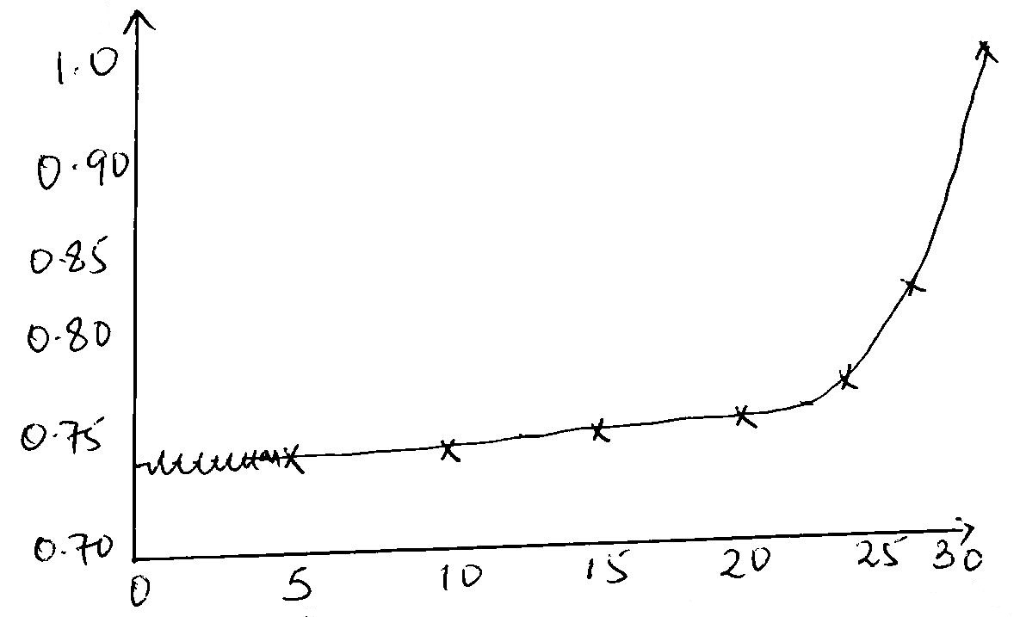

R.Q Values

Air temperature

1. Using information in the graph explain the relationship between RQ and temperature. (04 marks)

………………………………………………………………………………………………………………………………………………………………………………………………………………………………………………………………………………………………………………………………………………………………………………………………………………………………………………………………………………………………………………………………………………………………………………………………………………………………………………………………………………………………………………………………………………………………………………………………………………………………………………………………………………………………………………………

1. State circumstances under which RQ would be over 1.0. (01 mark)

………………………………………………………………………………………………………………………………………………………………………………………………………………………………………………………………………………………………………………………………………………………………………………………………………….

1. State two reasons why theoretical RQ values of the different food substances are not realistic. (02 marks)

……………………………………………………………………………………………………………………………………………………………………………………………………………………………………………………………………………………………………………………………………………………………………………………………………………………………………………………………………………………………………………

1. (a) (i) What is meant by the term feed back mechanism ? (03 marks)

……………………………………………………………………………………………………………………………………………………………………………………………………………………………………………………………………………………………………………………………………………………………………………………………………………………………………………………………………………………………………………

(ii) State three functions of homeostatic control in cells (03 marks)

…………………………………………………………………………………………………………………………………………………………………………………………………………………………………………………………………………………………………………………………………………………………………………………………………………………………………………………………………………………………………………………………………………………………………………………………………………………………………………………………………………………………………………………

(b) Explain the role of feed back mechanism in the generation of an action potential along the axon membrane. (04 marks)

………………………………………………………………………………………………………………………………………………………………………………………………………………………………………………………………………………………………………………………………………………………………………………………………………………………………………………………………………………………………………………………………………………………………………………………………………………………………………………………………………………………………………………………………………………………………………………………………………………………………………………………………………………………………………………………

1. Disruptive selection occurs in one species of rabbits where in the population large female mate only with large males and vice versa. intermediate have a low survival rate
2. (i) Sketch a graph to show the distribution in size of the rabbits as a result of disruptive selection. (03 marks)

(ii) Explain how disruptive selection has been maintained in this species of rabbit (04 marks)

………………………………………………………………………………………………………………………………………………………………………………………………………………………………………………………………………………………………………………………………………………………………………………………………………………………………………………………………………………………………………………………………………………………………………………………………………………………………………………………………………………………………………………………………………………………………………………………………………………………………………………………………………………………………………………………

1. Suggest how two different species of rabbit could a rose. (03 marks)

………………………………………………………………………………………………………………………………………………………………………………………………………………………………………………………………………………………………………………………………………………………………………………………………………………………………………………………………………………………………………………………………………………………………………………………………………………………………………………………………………………………………………………………………………………………………………………………………………………………………………………………………………………………………………………………

1. (a) State three adaptations of the circulatory system of a diving mammal. (03 marks)

……………………………………………………………………………………………………………………………………………………………………………………………………………………………………………………………………………………………………………………………………………………………………………………………………………………………………………………………………………………………………………

(b) Explain why ventilation is initially hampered at high altitude. (04 marks)

………………………………………………………………………………………………………………………………………………………………………………………………………………………………………………………………………………………………………………………………………………………………………………………………………………………………………………………………………………………………………………………………………………………………………………………………………………………………………………………………………………………………………………………………………………………………………………………………………………………………………………………………………………………………………………………

(c) State three physiological differences between the respiratory system of a human being and an insect. (03 marks)

…………………………………………………………………………………………………………………………………………………………………………………………………………………………………………………………………………………………………………………………………………………………………………………………………………………………………………………………………………………………………………..

1. (a) (i) State three differences between carbohydrates and lipids.

(03 marks)

………………………………………………………………………………………………………………………………………………………………………………………………………………………………………………………………………………………………………………………………………………………………………………………………………………………………………………………………………………………………………………………………………………………………………………………………………………

(ii) State three physiological functions of carbohydrates in plant life .

(03 marks)

…………………………………………………………………………………………………………………………………………………………………………………………………………………………………………………………………………………………………………………………………………………………………………………………………………………………………………………………………………………………………………………………………………………………………………………………………………………………………………………………………………………………………………………

(b) Explain how fattyacids are modified to reach the blood stream in mammals. (04 marks)

………………………………………………………………………………………………………………………………………………………………………………………………………………………………………………………………………………………………………………………………………………………………………………………………………………………………………………………………………………………………………………………………………………………………………………………………………………………………………………………………………………………………………………………………………………………………………………………………………………………………………………………………………………………………………………………

**END**